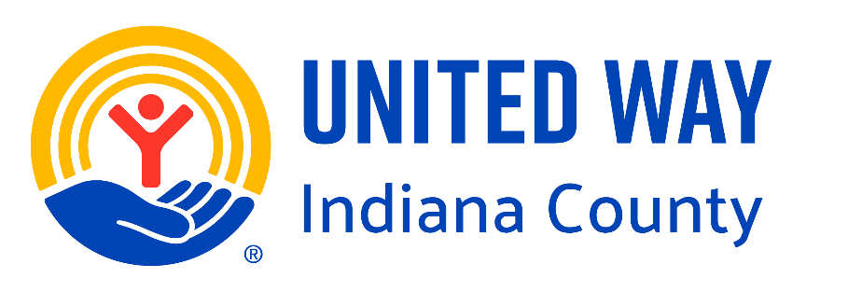

2027 United Way Agency Program Allocation Application

Agency Name: ______________________________________
Program Name: ______________________________________
Total Program Cost: $_________________________________
Funds Requested: $ __________________________________
Funds Received in prior year: $_________________________

Section 1: Agency Information

Agency Name:

Mailing Address:

EIN:

Website:

Contact Name and Title:

Phone: Email

Executive Director:

Phone: Email

We certify that we maintain current certificates of registration from the PA Department of State, Bureau of Charitable Organizations: ☐YES ☐NO If no, please explain.

The following questions relate to the Participation Agreement between your agency and the United Way:
- We have conducted an Indiana County UW Employee Campaign ☐YES ☐NO

- We have participated in the following United Way activities: ___Kick Off; ___Pancake and Sausage Day; ____ Turkeython; Souper Bowl; ___ Annual Meeting; ___Other (please describe)

- We have acknowledged the UWIC funding in our promotional materials for the funded program/s, including but not limited to social media, newspaper, and program brochures and/or flyers as applicable. ☐YES ☐NO

By signing this application, I certify that all information is true and accurate to the best of my knowledge:

Executive Director (print) Board President (print)

Signature Signature

Date: Date:

Section 2: Diversity, Equity, and Inclusion

The United Way Board of Directors is evaluating our practices to ensure cultural competence is evident in our operations as well as funding decisions that help to advance diversity, equity and inclusion in Indiana County.

We are asking all partner agencies to collect and report diversity data in your organization in order for us to measure the impact of the work in supporting programs that address disparities in the county. We encourage partner agencies to foster diversity and inclusion practices to help drive DEI progress toward achieving positive social change. Tracking demographics relating to diversity is important and beginning next year we will be collecting data regarding DEI.

- State the number of people you serve as an agency.

- Select all demographics you are currently tracking for diversity across your entire agency?
☐Age ☐Gender ☐Income ☐Education Level ☐Religion ☐Race ☐Ethnicity ☐Marital Status ☐Location ☐Employment Status ☐Veteran Status ☐Language ☐Sexual Orientation
☐Other:

- What demographics are you planning to track for the proposed program?
☐Age ☐Gender ☐Income ☐Education Level ☐Religion ☐Race ☐Ethnicity ☐Marital Status ☐Location ☐Employment Status ☐Veteran Status ☐Language ☐Sexual Orientation
☐Other:

- From the categories above, list any important statistics regarding the population your agency serves (e.g. 60% of the population served is over 55 years old).

- What percentage of your United Way funded program participants are considered ALICE (Asset Limited, Income Constrained, Employed)? (for more information on this, please refer to https://www.uwindianacounty.org/alice )

- Share how your organization works to ensure equal access to services and operationalize nondiscriminatory practices to best meet the needs of those served. Provide specific examples such as staff training or professional development, organizational policies and practices, or programmatic modifications to adapt to different cultures.

Section 3: Program Description

Program Start Date: _____________________ End Date: _______________________

- The following are the Impact Pillars being addressed by the United Way of Indiana County. Choose the ONE your proposed program will address.

☐ Housing Instability & Homelessness
☐ Food Insecurity
☐ Transportation Barriers
☐ Mental & Behavioral Health Needs
☐ Child Care & Youth Support

- Describe services to be provided including who performs the work, how many staff provide the service in Indiana County, what service/s are provided, length of service and frequency, where it is provided and when it is offered in Indiana County (ie. Daily, 1 day/week), the overall goal of the program, and any other information relevant to explaining the program. Be as descriptive as possible.

- What is the target population this specific program will serve and what are the eligibility requirements?

- How many individuals in Indiana County will be directly served by this specific program?

- If this program is provided in multiple counties, what is the total number of individuals who will be directly served by this program?

- How was this need identified specifically for Indiana County? (ie. Survey results, statistics, etc).

- What data collection methods will you use to assess the outcomes to identify success? Please attach a copy of any assessments you will use to help the allocations team understand your program better.

- How does this program help to solve a community need within the selected impact area from question #7?

- What other organizations do you regularly meet or talk with to coordinate services to collaborate for program effectiveness and help your clients achieve success?

- Are volunteers used to carry out this program? If so, please note the approximate number used and list job titles or describe their roles in general to help us understand how they help. What needs do you have, if any, for additional volunteers?

Please check all Zip Codes where this program will be physically provided in Indiana County

☐ 16211
☐ 16246
☐ 16256
☐ 15681
☐ 15701
☐ 15705
☐ 15710
☐ 15712
☐ 15713
☐ 15714
☐ 15716
☐ 15717
☐ 15720
☐ 15723
☐ 15724
☐ 15725
☐ 15727
☐ 15728
☐ 15729
☐ 15731
☐ 15732
☐ 15734
☐ 15739
☐ 15741
☐ 15742
☐ 15745
☐ 15746
☐ 15747
☐ 15748
☐ 15750
☐ 15752
☐ 15754
☐ 15756

☐ 15758
☐ 15759
☐ 15761
☐ 15763
☐ 15765
☐ 15771
☐ 15772
☐ 15774
☐ 15777
☐ 15783
☐ 15920
☐ 15929
☐ 15944
☐ 15949
☐ 15954
☐ 15957
☐ 15961

Outcomes | Activities | Outputs | Data Collection Methods
Outcomes are a CHANGE in the target problem based on the intervention.  (e.g. increased knowledge) | Activities are used to address the target problem and will help create the CHANGE. | Outputs are only the number and percent of people you hope are served in each activity | How will you assess the CHANGES stated in the outcome column?
(e.g. All participants are trained in CPR and increase their knowledge surrounding CPR administration.) | (e.g. CPR Training for all participants) | (e.g. 55 (100%) participants will go through CPR training.) | (e.g. Pre and post testing for CPR; Role play session completion)
Section 4: Outcome Report

Section 5: Budget and Financial

- Has this program been funded in the past by United Way of Indiana County? ☐YES ☐NO

- What funding sources, aside from United Way of Indiana County, are directed to this program?

- Is your request for funding more than 10% of your allocation last year? ☐YES ☐NO
If yes, please provide an explanation of the need for these additional funds, including justifiable reasons why, if applicable, your budget shows reduced funding from other sources and/or an increased number of services are projected to be provided without available funding from other sources.

- What is the plan for sustainability of this project should United Way funding decrease or be eliminated?

Overhead Ratio: Please complete ONE of the following:

IRS Tax Form 990

- Part IX, Line 25, Column C (M&G Expense) + Column D (Fundraising Expense)
Divided By
- Part VIII, Line 12, Column A (Total revenue)

Overhead %

- OR -

IRS Tax Form 990-EZ

- Part 1, Line 17 (Total expenses) - Part 1, Line 10 (Grants Paid) - Part 1, Line 11 (Benefits to or for Members)
Divided By
- Part 1, Line 9 (Total Revenue)

Overhead %

The following questions regarding your unit cost and the number of service units to be provided in Indiana County are to be answered based on the total cost for the program in Indiana County. Calculate this information using all budgeted revenue, not just on the funding from the United Way. This information is essential in communicating scope of service that can be provided at various donation levels.

- What is your total proposed program expense from your UWIC Proposed Budget attachment, line E36?

- What has your agency determined to be the “unit of service” for this program? (i.e., one hour of counseling, each visit to the program, one session whether it is one time or a six-week class, days or nights of service, etc.).

- For your total Indiana County program budget using all funding sources, how many total units of service do you anticipate you will provide in Indiana County for the funding cycle?

- What is the cost per unit of service? (Total program expenses (from Question #1 above) divided by the total number of units (from Question #3 above).

- As part of our communication strategy to potential donors, it is critical to create a picture of how their donation is used and the impact it can have. For this program, please provide a concise statement of what you can do with the following dollar amounts. (Be as specific as possible. This helps us talk about YOUR program during campaign presentations!)

$25

$50

$100

$500

- Is there any additional information you would like to add to your application?

